Lokator League Benefits

What does my pitcher receive when joining the league?

2+ HOURS of Indoor Balls N Strikes Mound Time  Every pitcher will receive 5 sessions of bullpens, totaling 2 hours of mound work. Every pitch is thrown to a customized Lokation during the league and will be documented and filed in an individualized folder created just for your pitcher. Compare cage rental fees with Lokator League fees to see how they match up.  Compare Rental | Individual Pitch Lokation Statistics and Rankings  Each pitcher will receive all Lokator Accuracy Reports and Rankings immediately following bullpens thrown. This will allow pitchers to see how they match up with others in the league and get very specific reports detailing individual strengths and weaknesses.  Lokator Reports | Understand the Art of Pitching  All pitchers learn Lokations they need to hit, that's pitch command. They learn how to select pitches that get outs, that's pitch selection. They learn which pitches go well together, that's pitch sequencing.  Art of Pitching

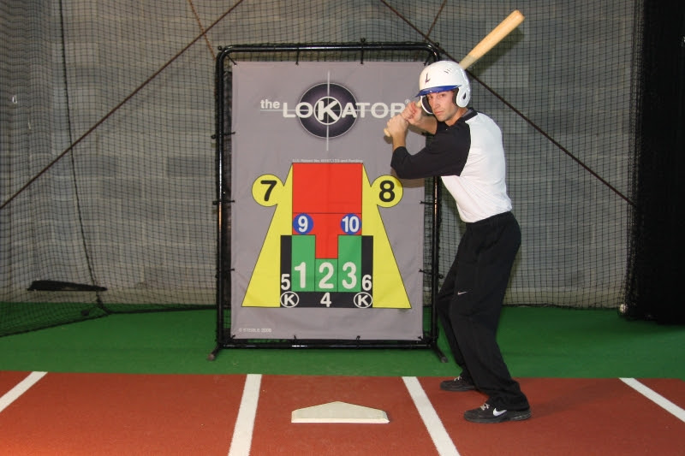

Email Jeremy Cummings Jeremy@LokatorAcademy.com or call Balls N Strikes Sports Academy at 501.833.0668 for more information.

