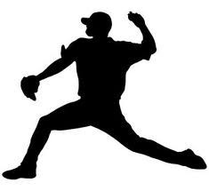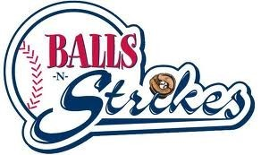
Arm Strengthening & Conditioning Program
This proven 4 week progressive program was developed by our staff of ex-professional baseball players & coaches. The primary goal of Pro Arm Plus is to teach the players proper arm care that helps prevent injury while improving athleticism, strength, and overall velocity.
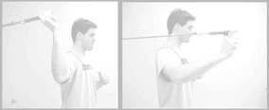

This program will focus on: Arm Action, Arm Care, Posture, Rhythm & Tempo, Separation, Torque, Core Strength, Sequencing and Synchronization. This program incorporates the use of bands, ropes, medicine balls, weighted balls, kettle balls, hurdles, and more!

4 week progressive program  2 Sessions per week  Classes Start on Tuesday at 7:00 – 8:00  and Thursday at 7:00 – 8:00  $99 per session | December session (12/10/2013 – 1/2/2014)  January session (1/7/2014 – 1/30/2014)  February session (2/4/2014 – 2/27/2014)  March session (3/4/2014 – 3/27/2014)  April session (4/1/2014 – 4/24/2014)  May session (4/29/2014 – 5/22/2014)  June session (5/27/2014 – 6/19/2014)  July session (6/24/2014 – 7/17/2014)  August session (7/22/2014 – 8/14/2014)
Pro Arm Plus  Name______________________ Age______  Address______________________________  City_____________ State____ Zip________  Email________________________________  Phone________________________________  http://www.bnssports.us/sherwood.php | Call us at (501)-833-0668 to  register, or drop off form to:  Balls-N Strikes 408 Manson  Road Suite 450 Sherwood,  AR 72120  Limited to first 12 per class

