Christmas Break Training
Ages 7-10
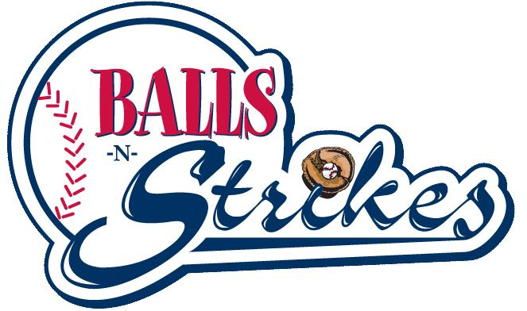
School is out, but baseball never stops! Christmas Break training is designed to jump start your spring season through group training and high repetition. Classes will be taught by our staff of ex-college and professional players, all of which have experience coaching and instructing youth players. Christmas Break Training is a great time to prepare for the upcoming season. Get your player out of the house for a fun activity during their break from school.

.400 Hitters Club Pro Arm
Dates: December 19th – 22nd Dates: December 19th – 22nd
Time: 9:30 am – 11am (Drop off begins at 9am) Time: 11am – 12:30pm
Cost: $99* Cost: $99*
*Players enrolled in both .400 Hitters Club and Pro Arm will receive a combined discounted total price of $175

Infielders Defensive Camp Catchers Camp
Dates: December 28th – 29th Dates: December 28th – 29th
Time: 9:30 am – 11am (Drop off begins at 9am) Time: 11am – 12:30pm
Cost: $49 Cost: $49

Enrollment
To enroll, please call us at 501-833-0668 or register in person during our regular business hours. Disclaimer – All participants must sign a waiver at the front desk to participate.

