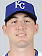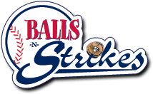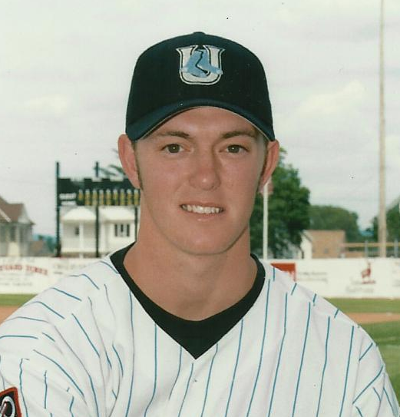

Catchers and Hitters Camp
Cody Clark January 22, 2011 Ronnie Goodwin
9:30 am – 12:30 pm
Cost $75
Catcher KC Royals (AAA) Instructor at Balls N Strikes
Drafted by Toronto Blue Jays (2000) Drafted by Diamondbacks (1997)
Played at the Univ. of Arkansas (2001-02) Played at Westark Jr. College (1998)
Played at Wichita State Univ. (2003) Played at Ole Miss (1999-2001)
Drafted by Texas Rangers (2003) Drafted by Florida Marlins (2001)
Played for Texas Rangers, Atlanta Coached 8 years in College Baseball
Braves, and KC Royals Had 5 Players play Professionally

Catchers will learn: Stance, Receiving, Blocking, Footwork, and
Throwing
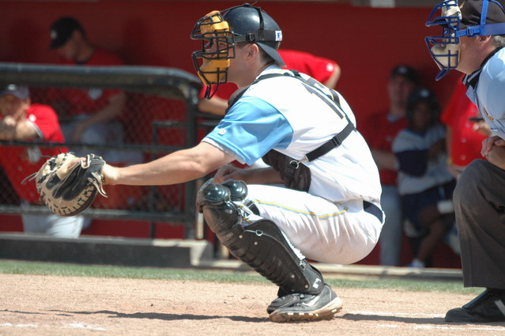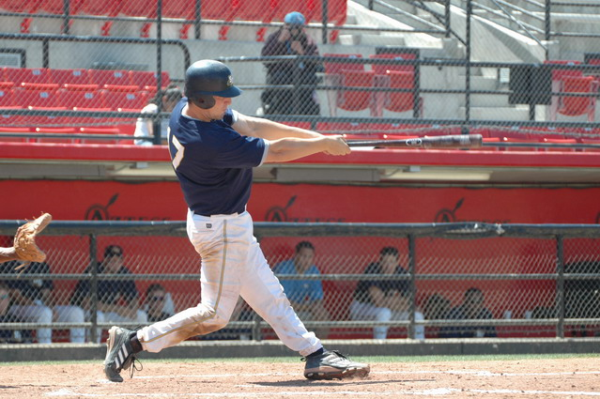
Hitters will learn: Stance, Balance, Posture, Swing
Mechanics, Rhythm & Timing, Connection, and Synchronization

Spaces are limited so call Balls N Strikes (501) 833-0668
or Ronnie Goodwin (501) 551-0560 to register.

